Ferguson, Ian Stewart (mainly based on Linked In)
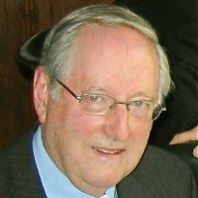

Graduated from Australian Forestry School in 1956. Worked in Forests Department in late 1950s-early 1960s. Yale University M F; D F, Forest economics and management 1962 – 1965. Resigned from Department in 1967/68. Did PhD.
Professor Emeritus of Forest Science & Forest Science at University of Melbourne, November 1981 – Present (32 years), Consultant.

